IBM Nalaiyathiran

Data Analytics: Assignment 1

Varsha B

Link to Implementation

https://us1.ca.analytics.ibm.com/bi/?perspective=explore&pathRef=.my_folders%2Fstartup%2Bexploration&subView=model00000183423b96cb_00000004

Exploration 1:

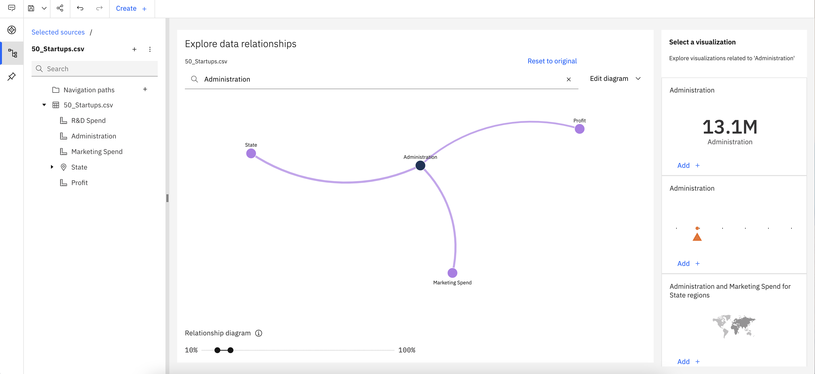

Exploration 2:

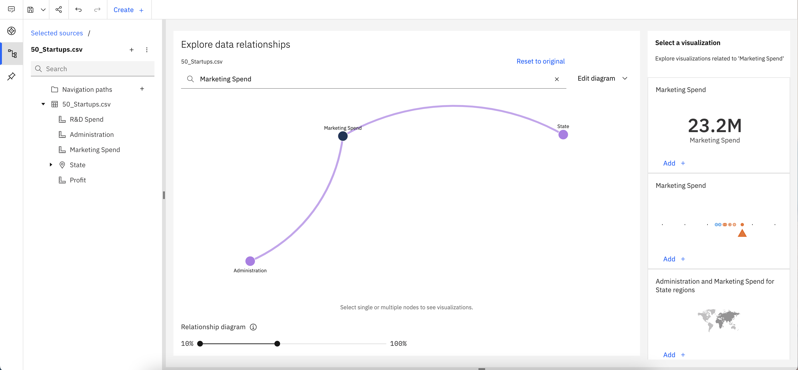

Exploration 3:

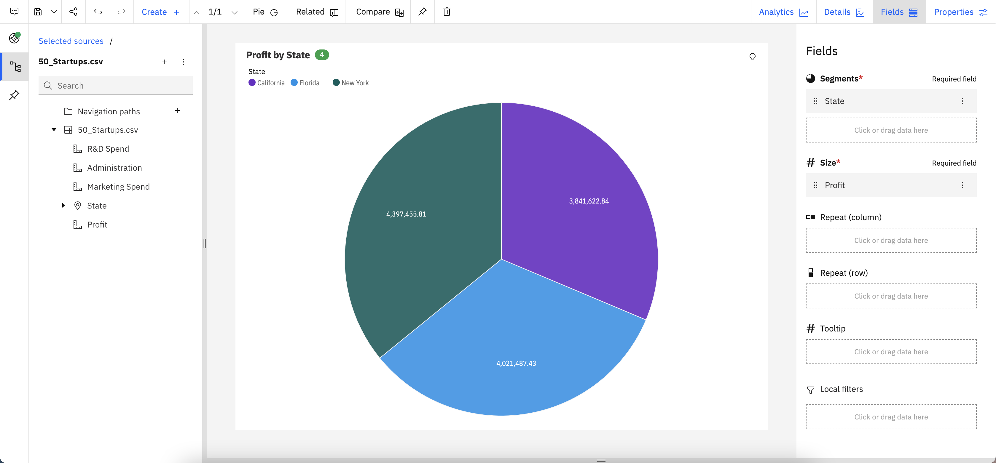

Exploration 4:

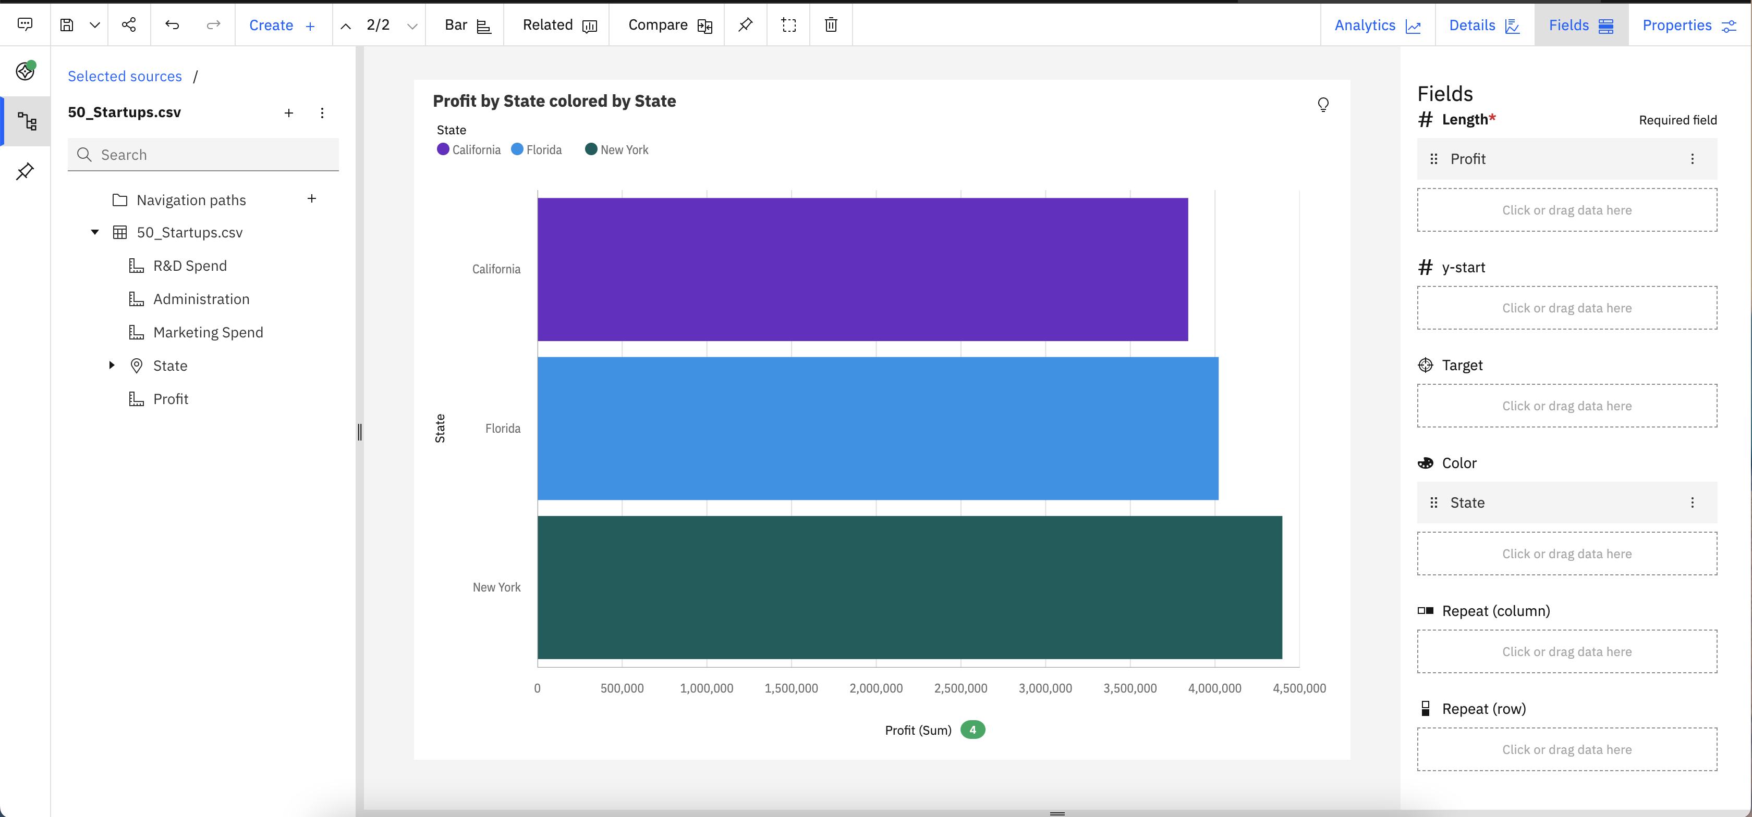

Exploration 5:

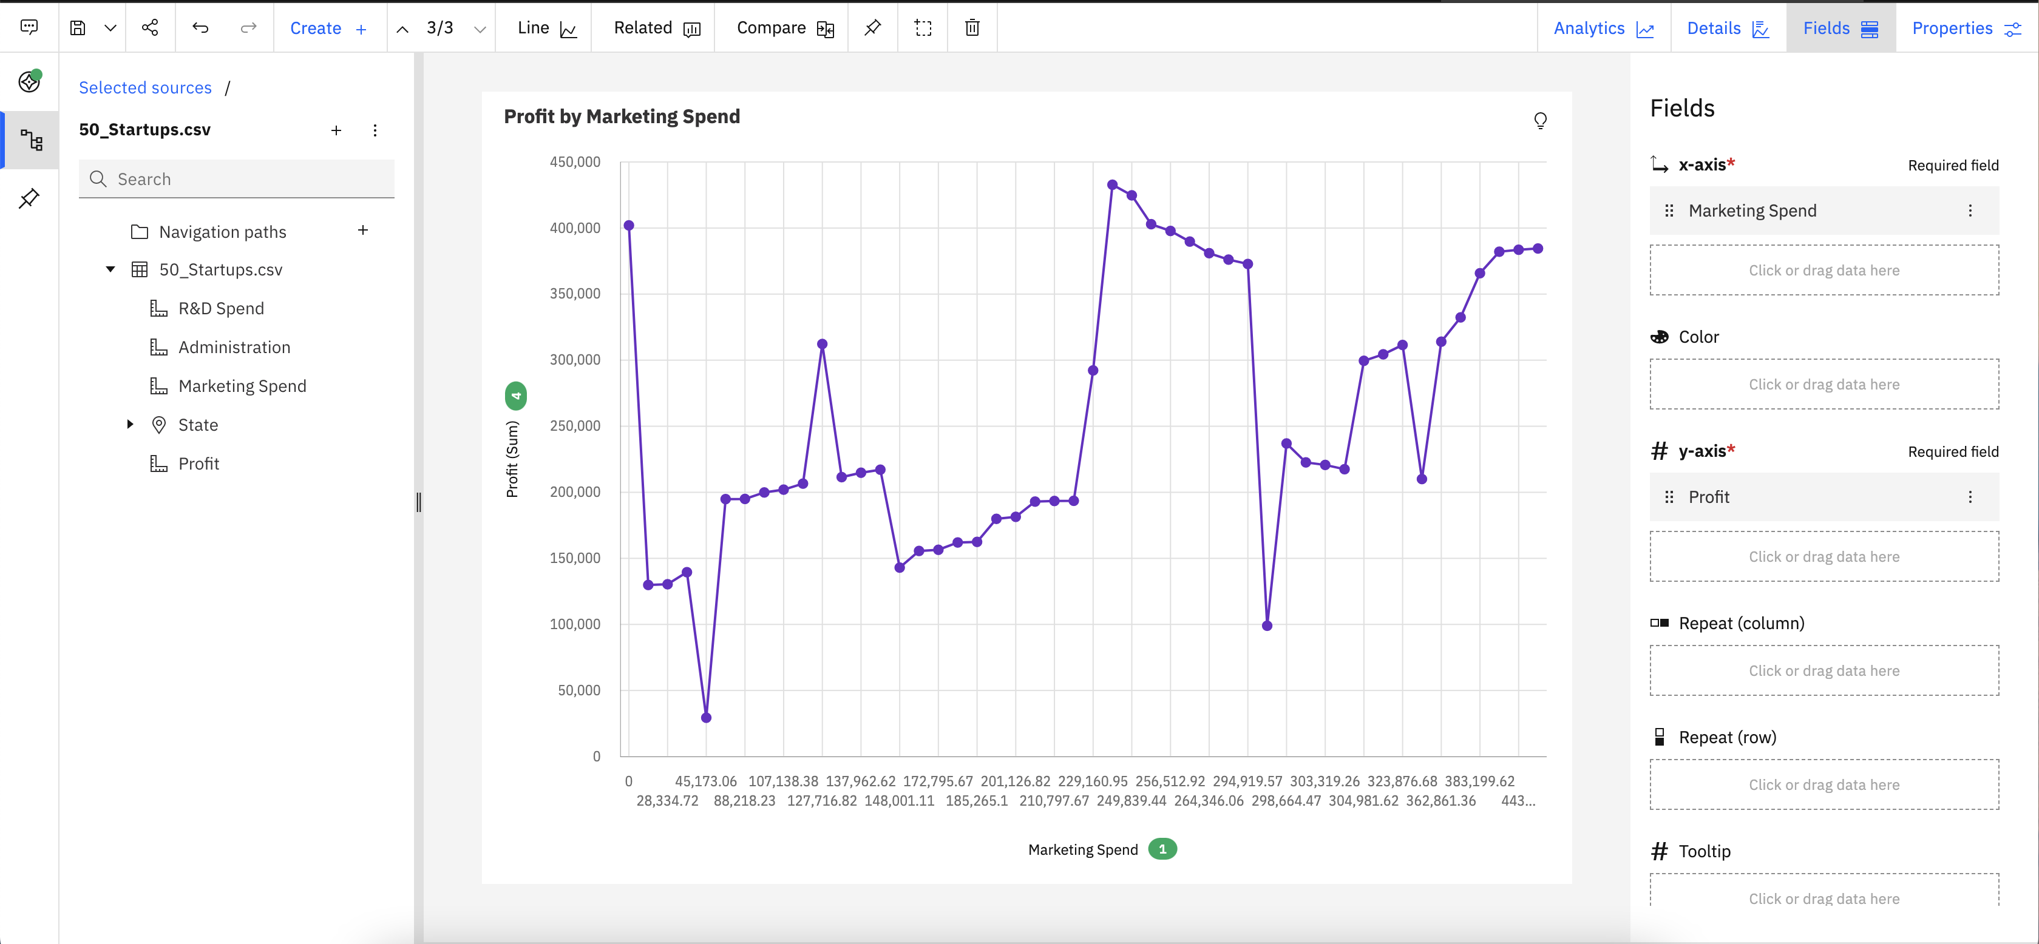

Exploration 6:

